CSA05-DATABASE MANAGEMENT SYSTEMS
LAB OBSERVATION
EXPERIMENT:04
AIM:
To perform Data Manipulation Language (DML) Commands such as UPDATE, DELETE in the table.
QUESTION:
1. Update the value of student name whose register number is ‘191711342’
SQL QUERIES:
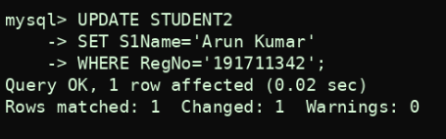
OUTPUT:
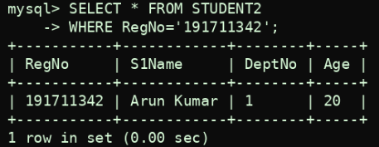
2. Delete the record in the table FACULTY, who resigned her job.
SQL QUERIES:
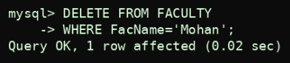
OUTPUT:
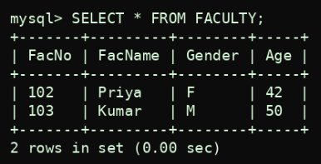
3. Modify the age for the faculty whose name is 'mohan' with a value ‘59’.
SQL QUERIES:
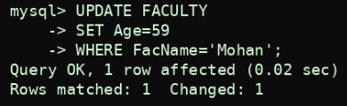
OUTPUT:
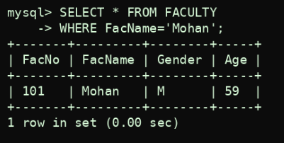
4. Remove all faculty who are having over 65 years
SQL QUERIES:
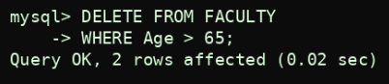
OUTPUT:
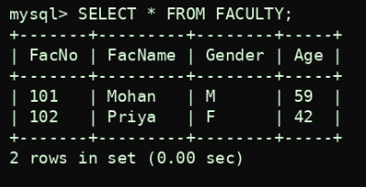
RESULT:
Data Manipulation Language (DML) Commands such as UPDATE, DELETE are performed in the five tables.

